Parallel operation instructions for multiple inverters HYD 3-6K-EP

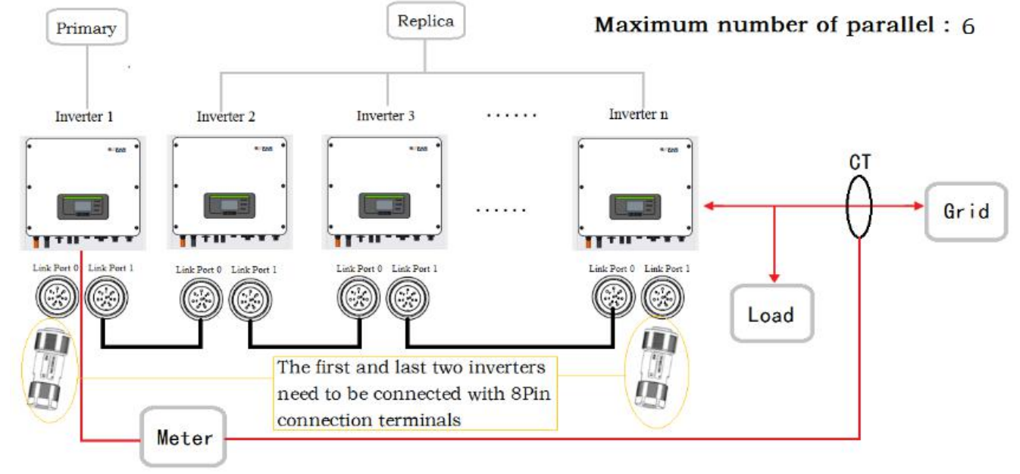

1. Single inverter wiring diagram
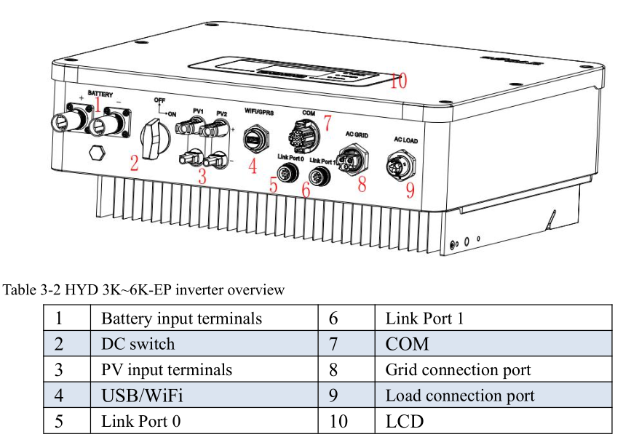

Steps：
1. Connect the battery, PV, grid, load, and connect to the COM port (see the manual for the definition of the COM port)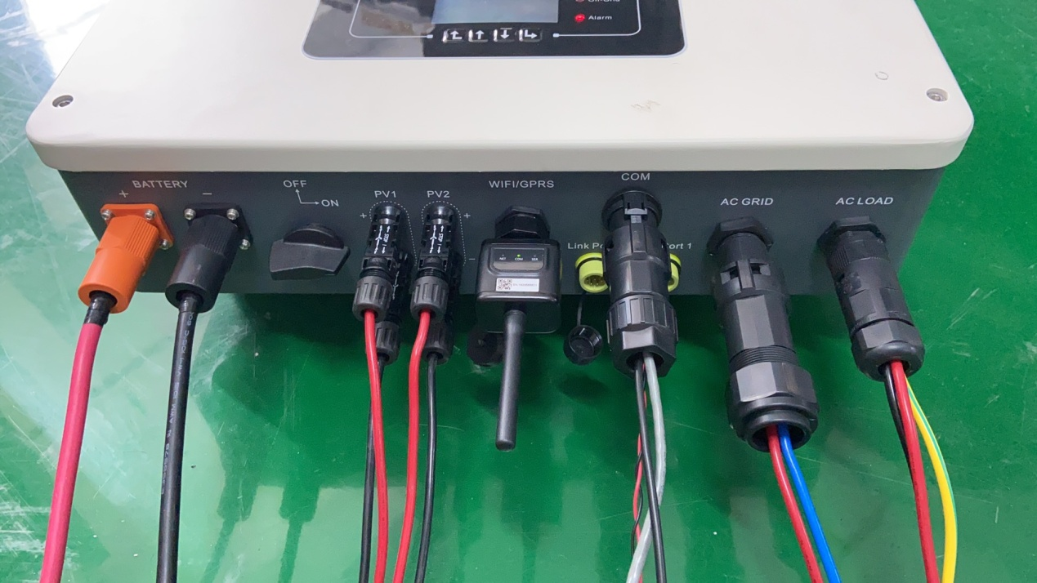
2. Turn on the battery power, turn on the DC switch, and the inverter's LCD screen will be on at this time, and it will enter the boot process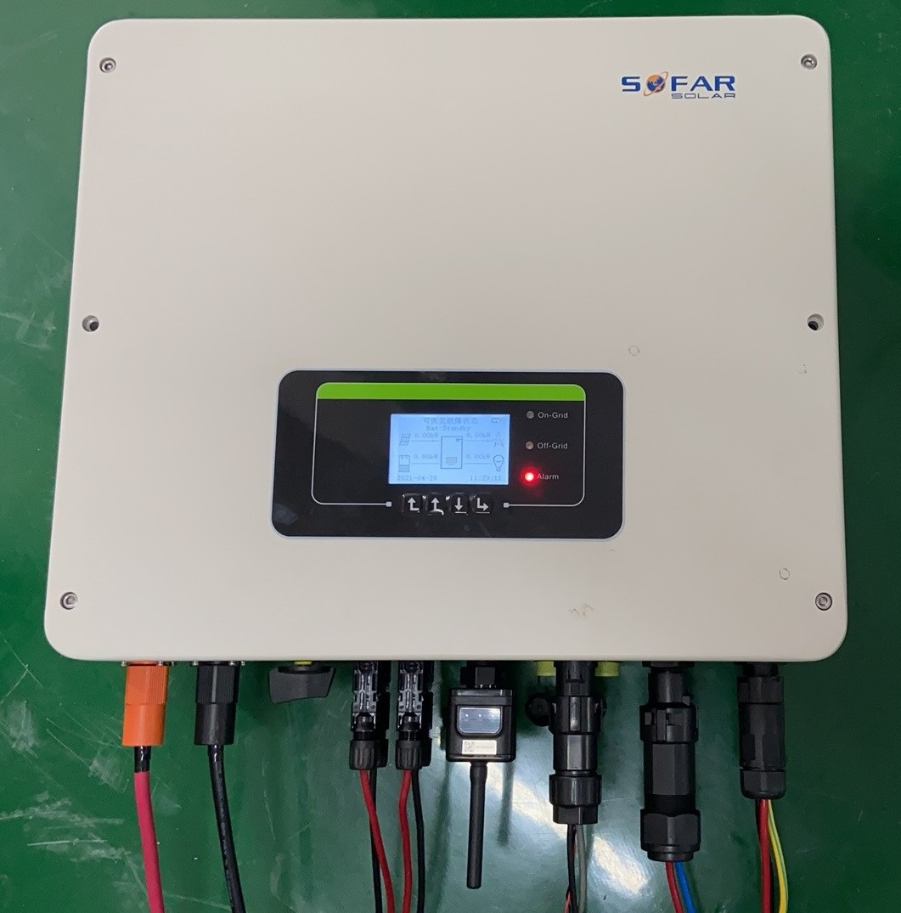

Boot process
Choose language
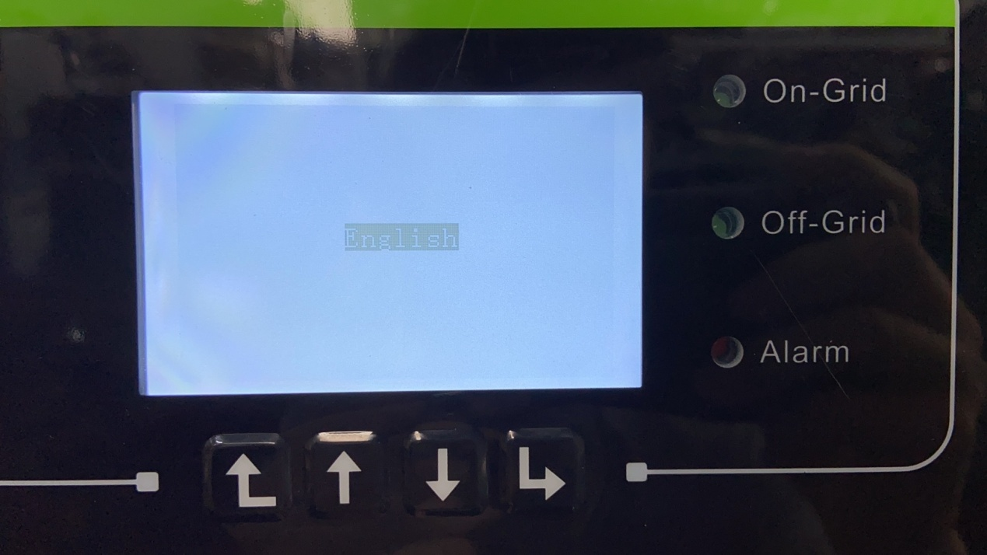
Insert USB (contains safety files)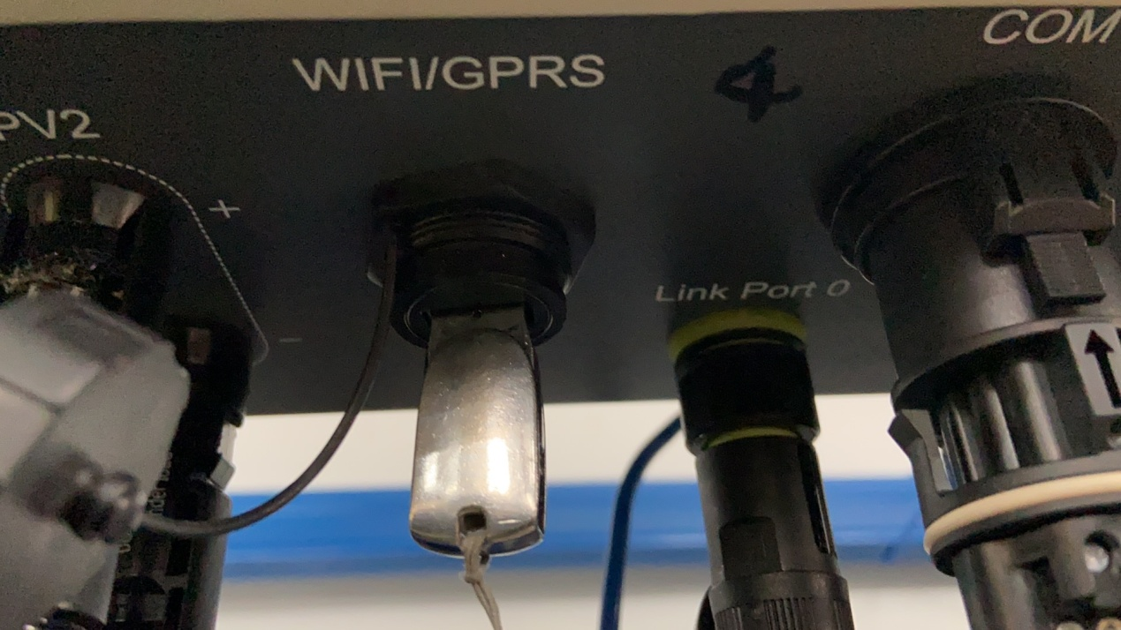

Set system time
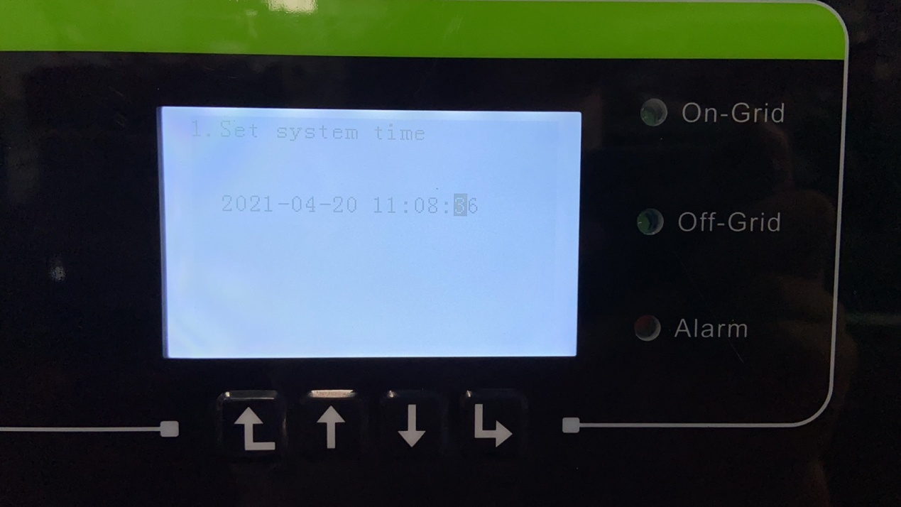
Select safety file
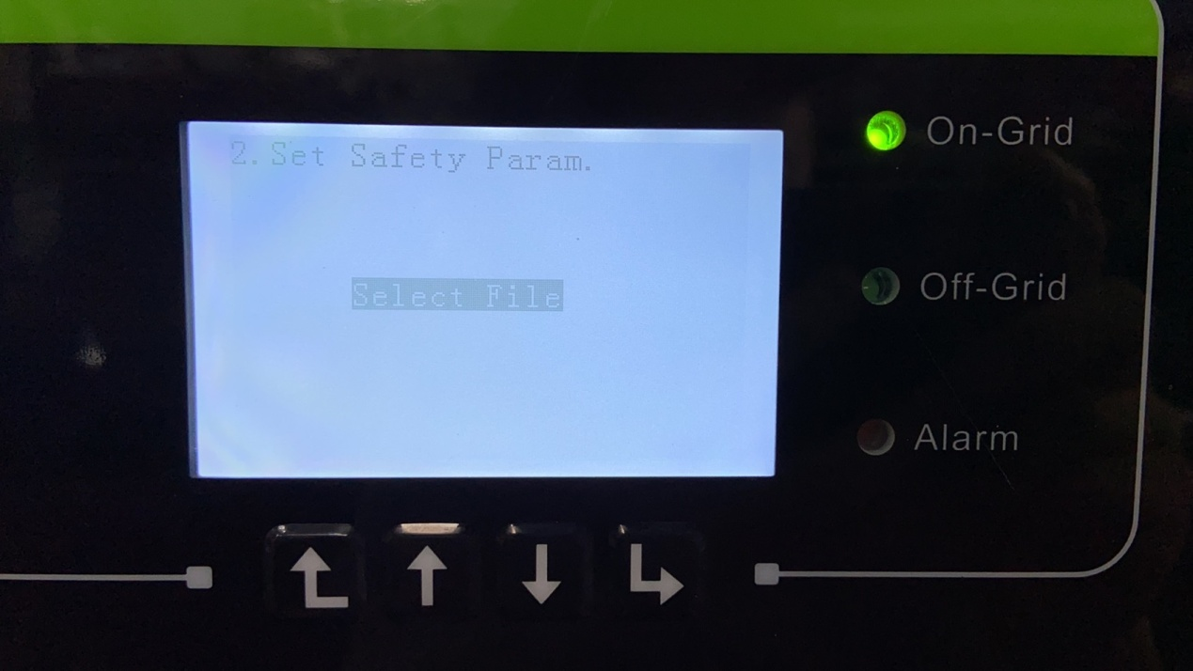

Select the corresponding safety file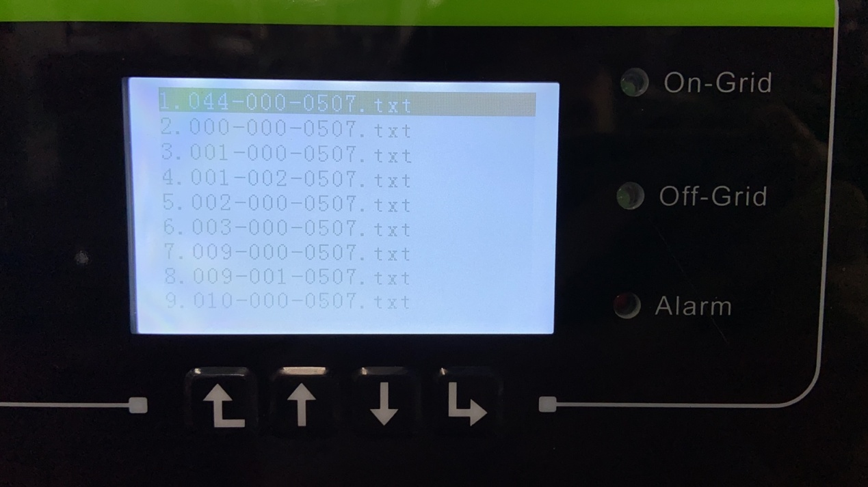
Set PV input mode（Independent/Parallel）
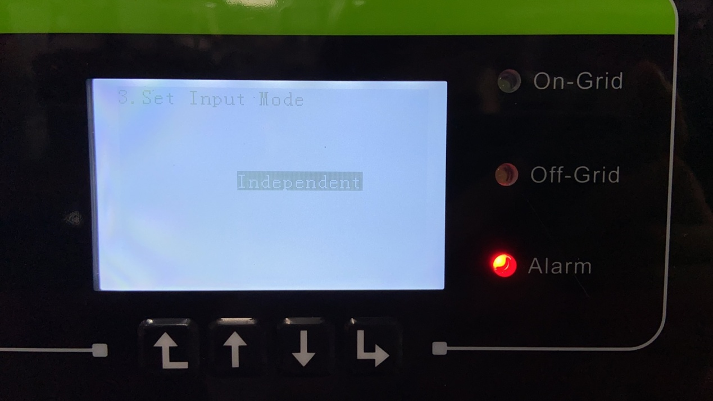
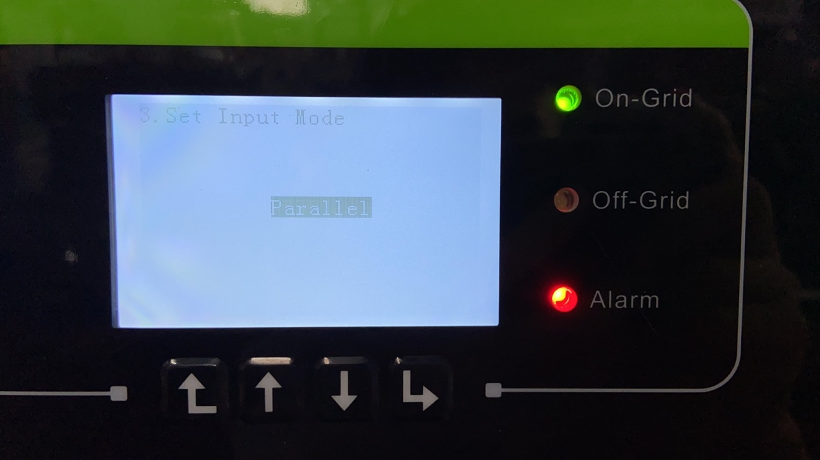
Set battery type
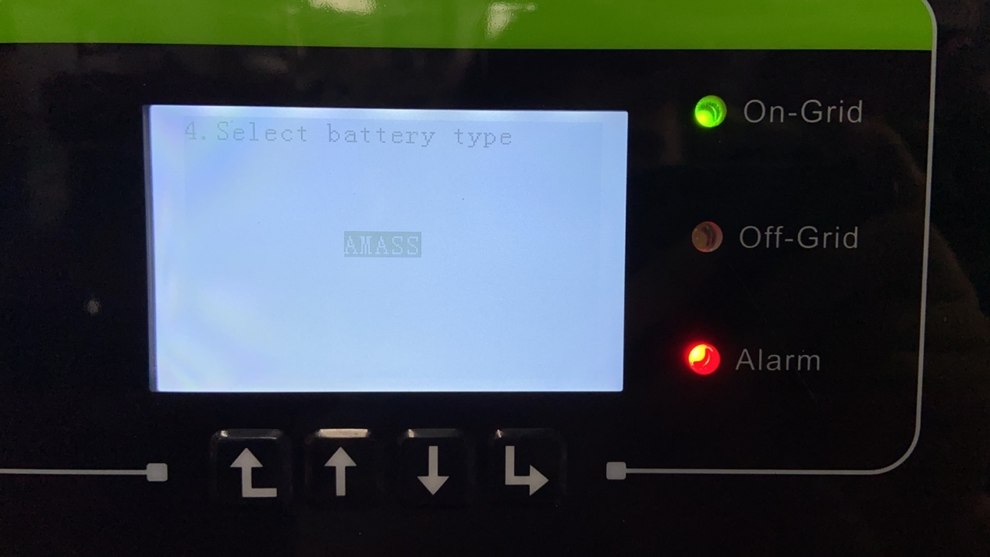
Set max battery charge current
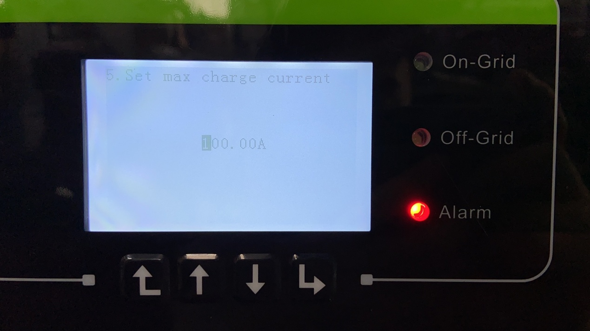
Set max battery discharge current
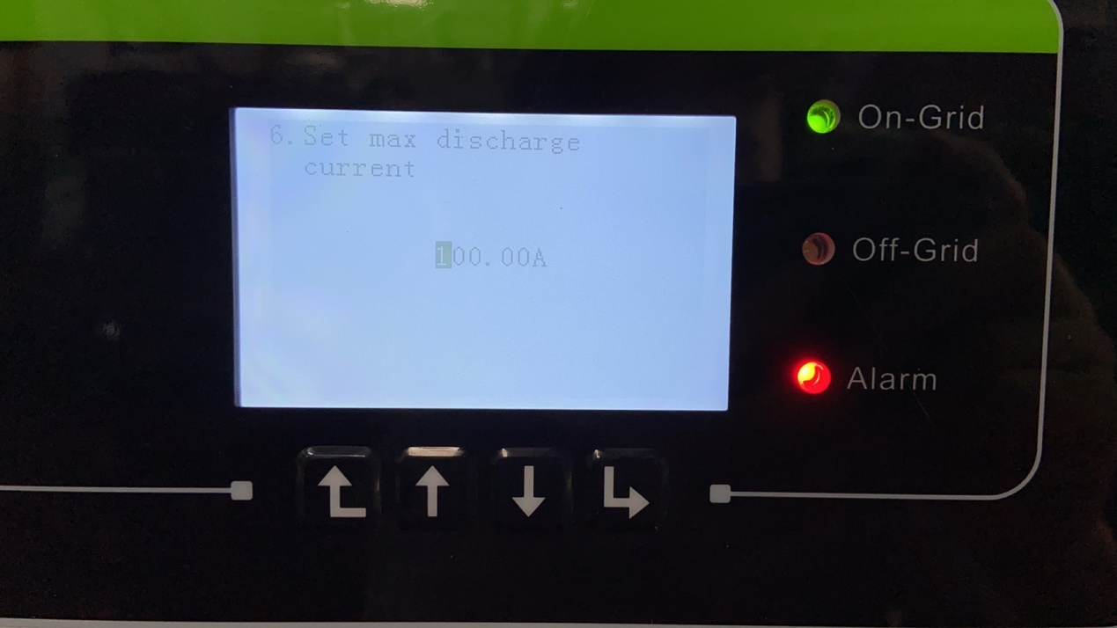

Set DOD, EPS DOD
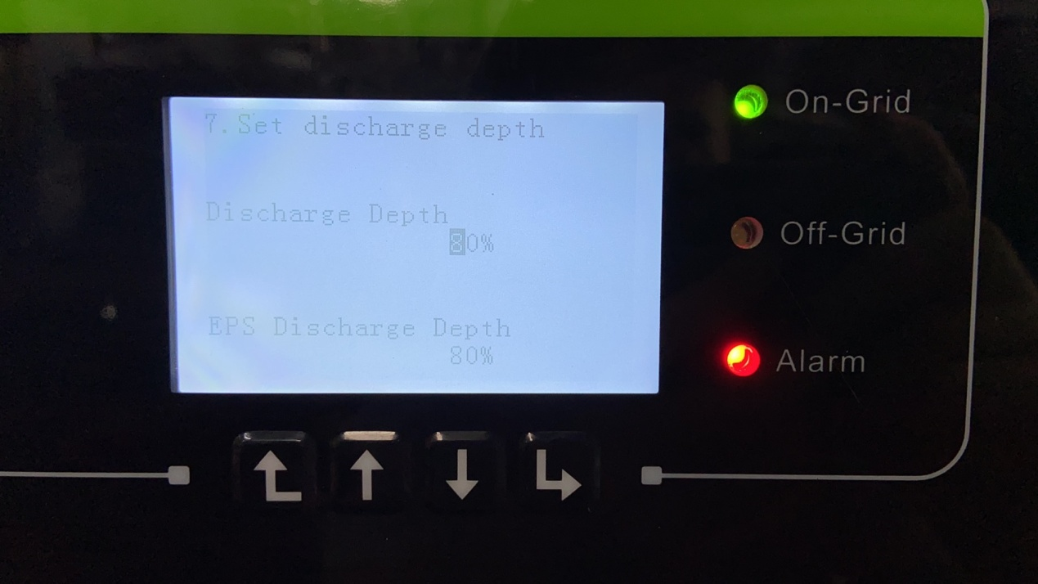
Enter the display interface, remove the USB, and plug in the WIFI/GPRS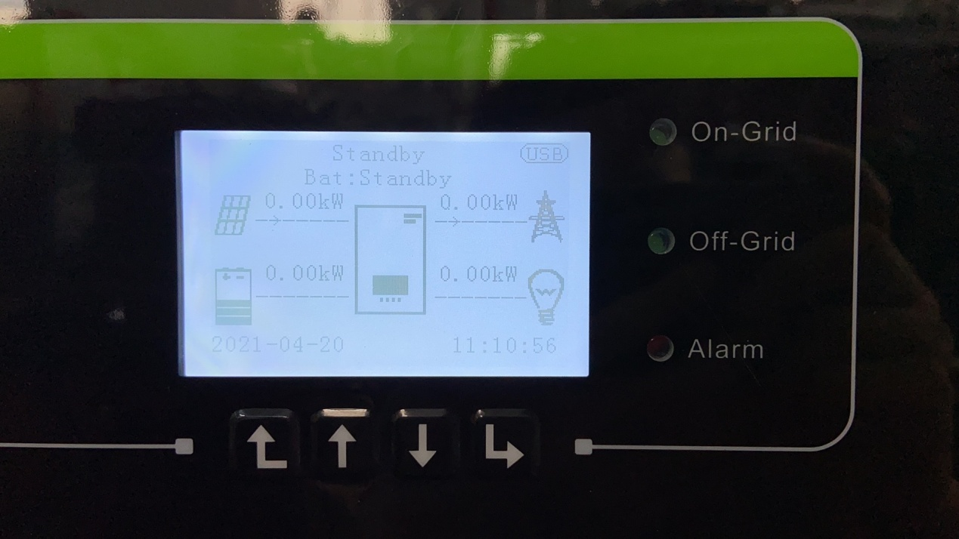

2. Steps to install multiple inverters in parallel
Install multiple inverters according to the above operation (currently up to 6 inverters), and then connect them end to end with parallel cables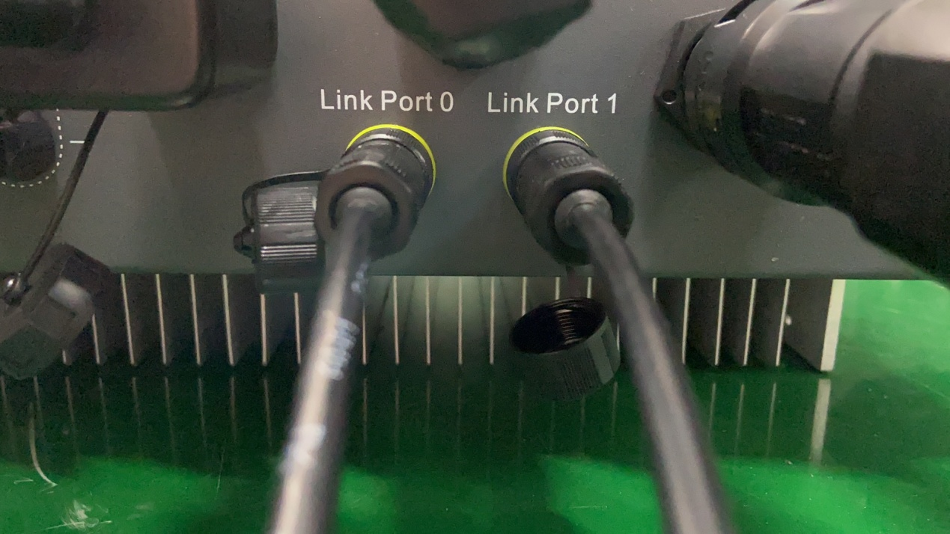

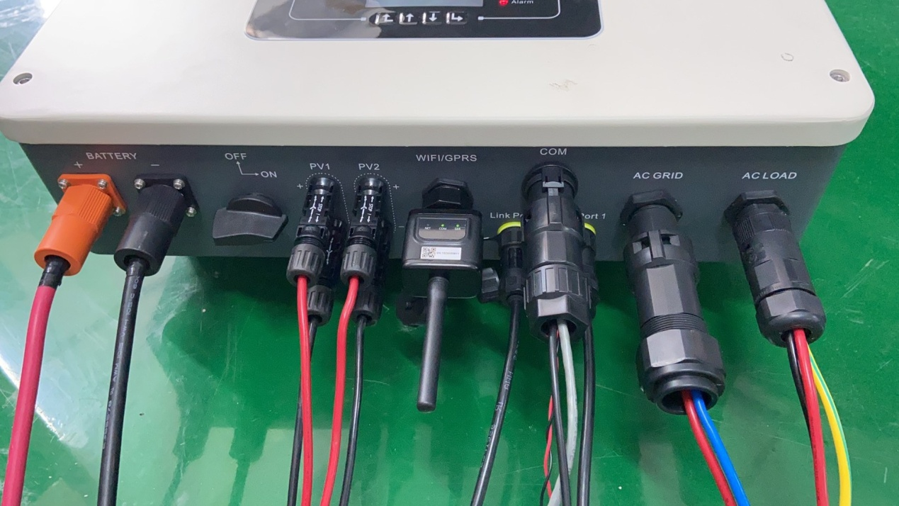

As shown in the figure below, 1 master, 5 slave inverters (only need to connect the CT/meter of the master inverter to the grid side)
Set master inverter
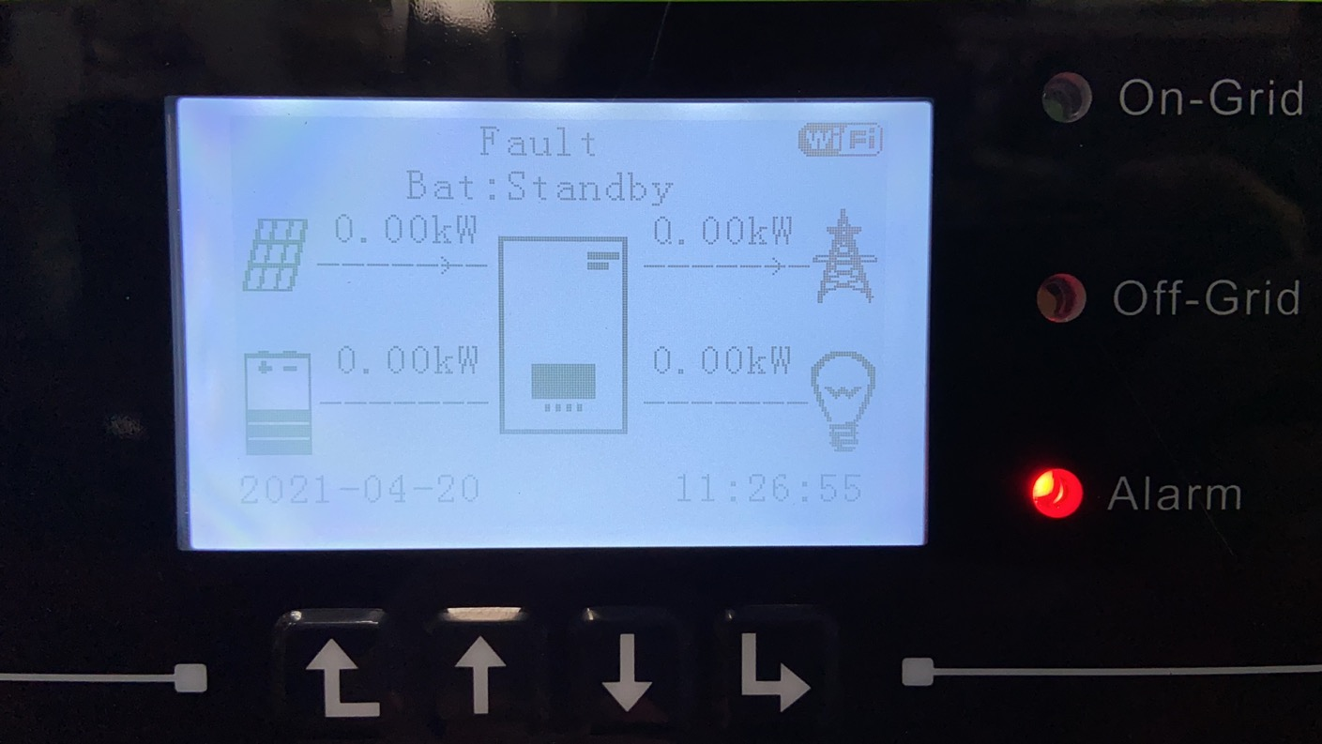
System Settings
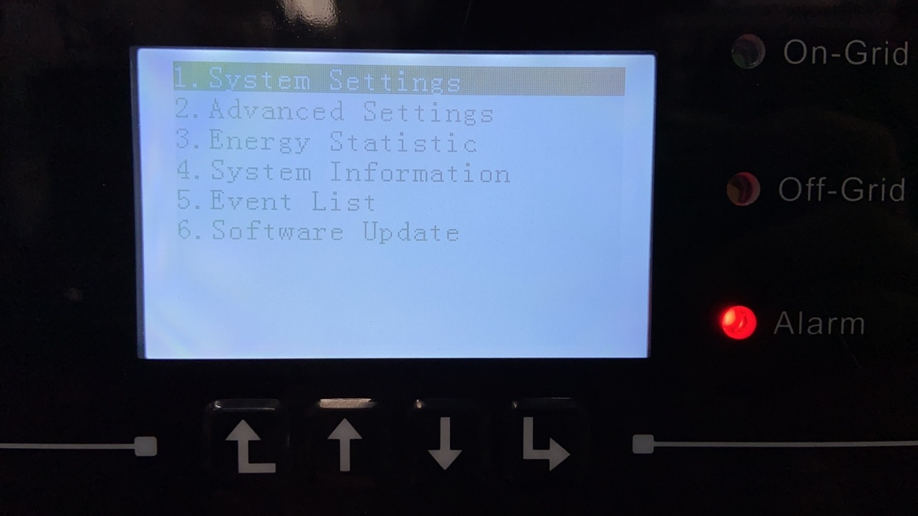
Select Advanced settings
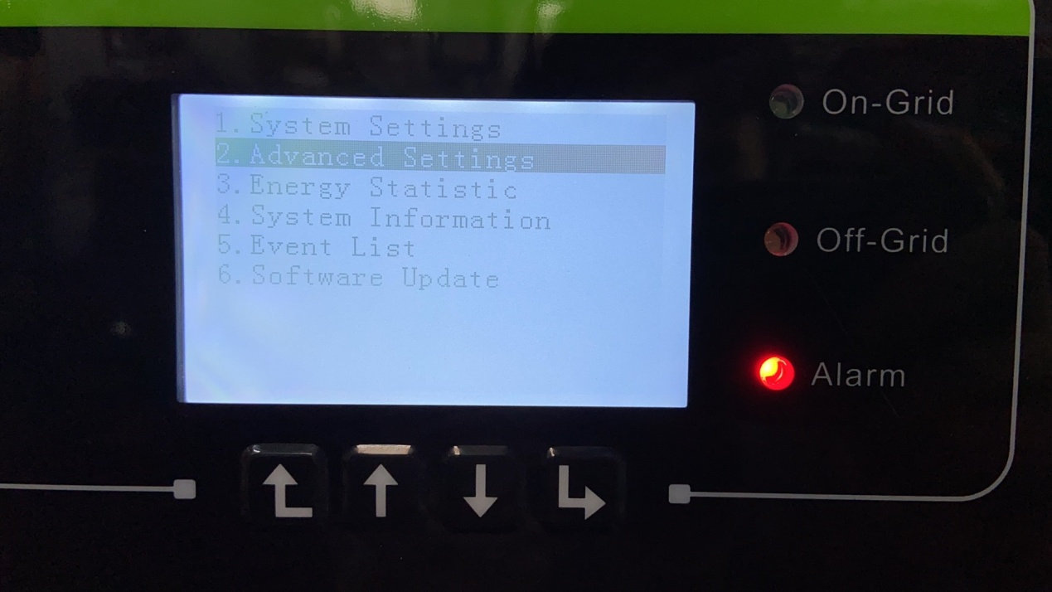
Password: 0715
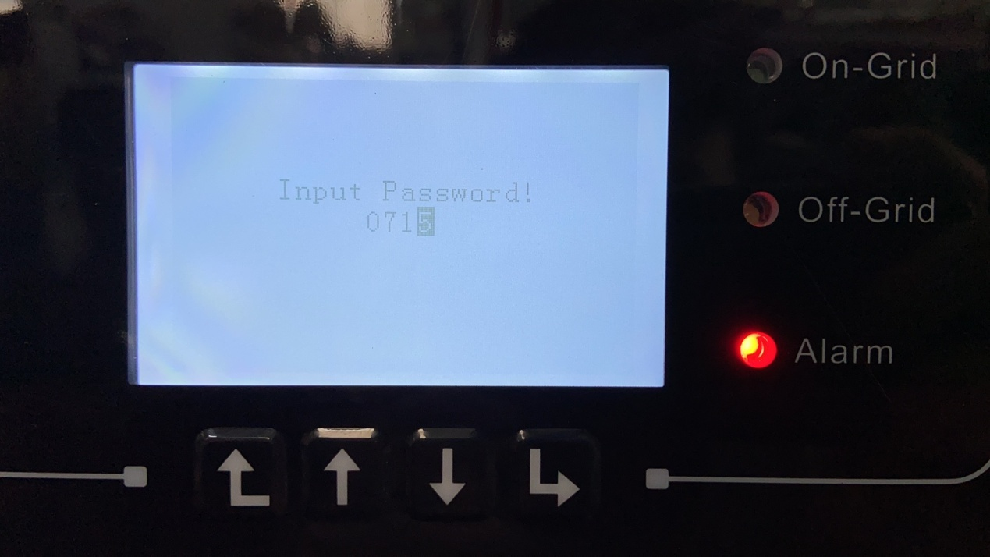
Select 6.Parallel settings
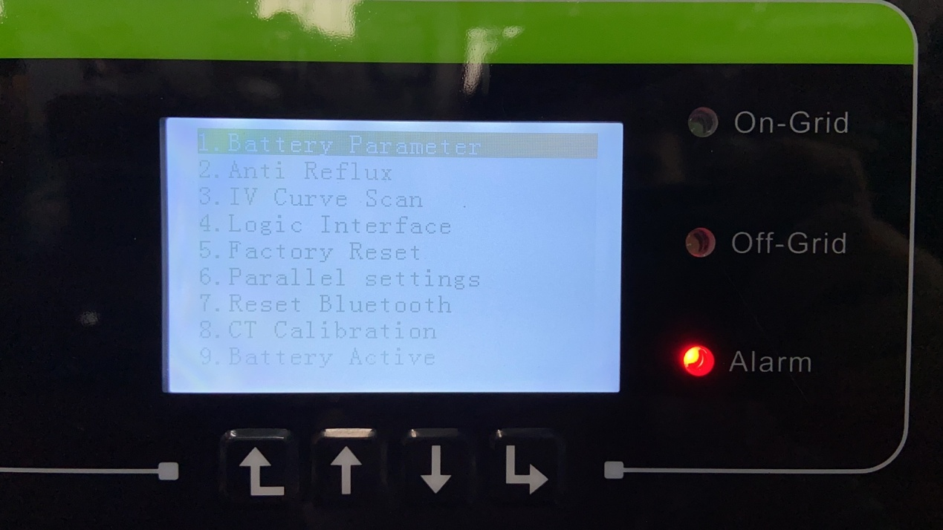
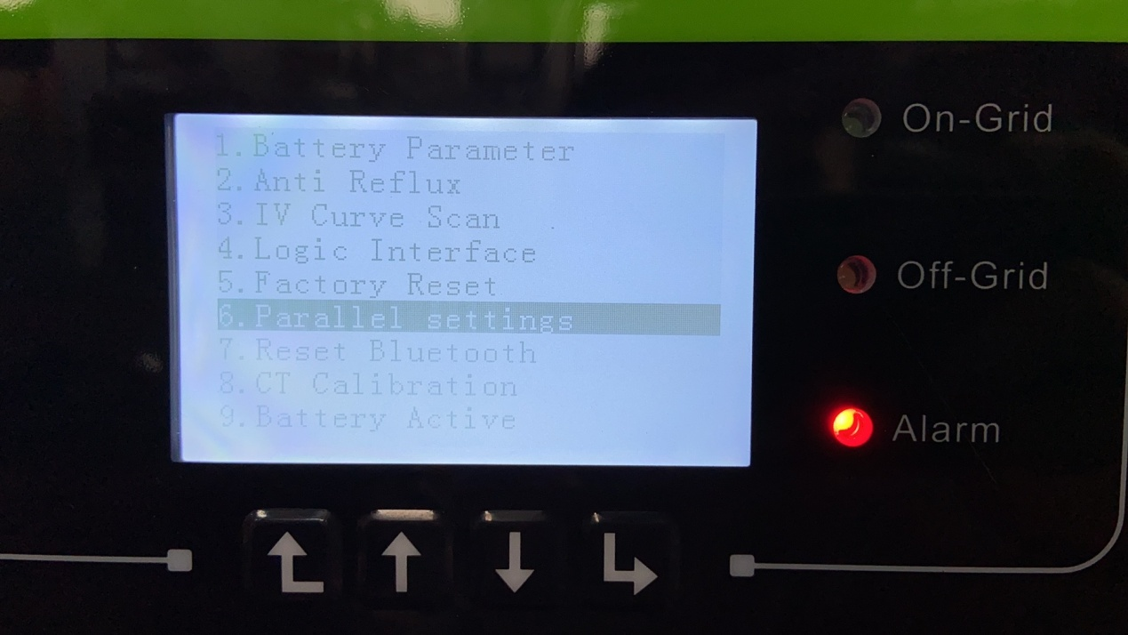
1. Parallel Control
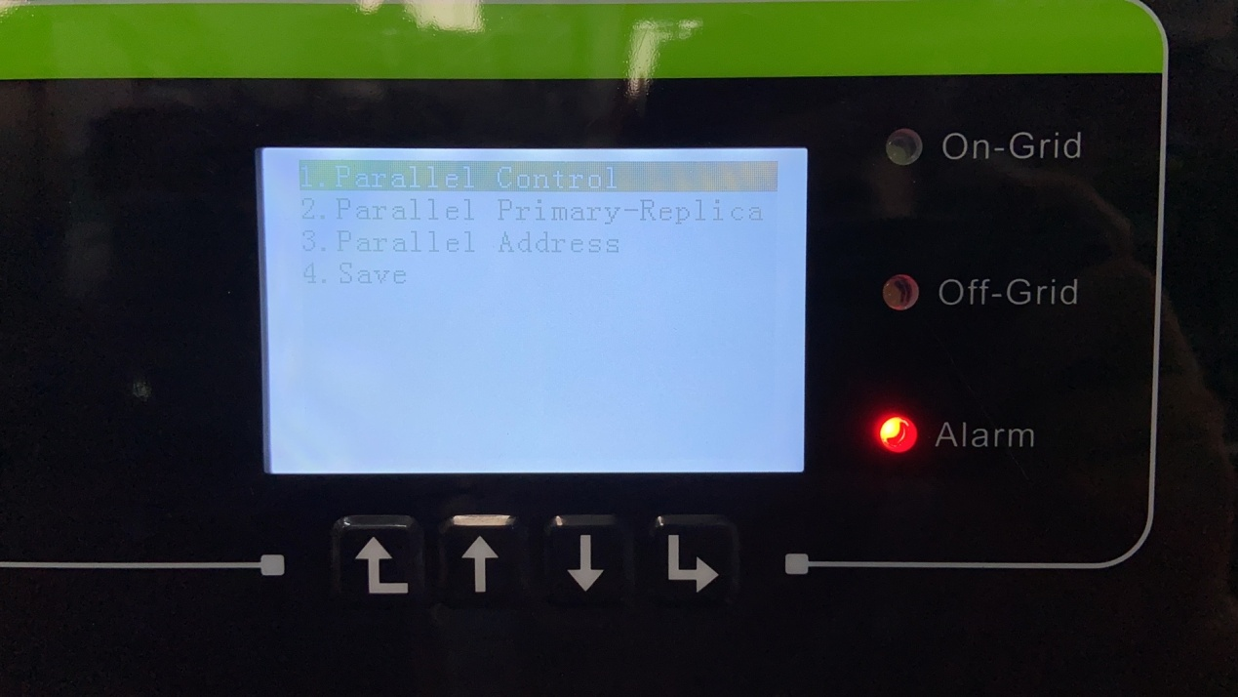
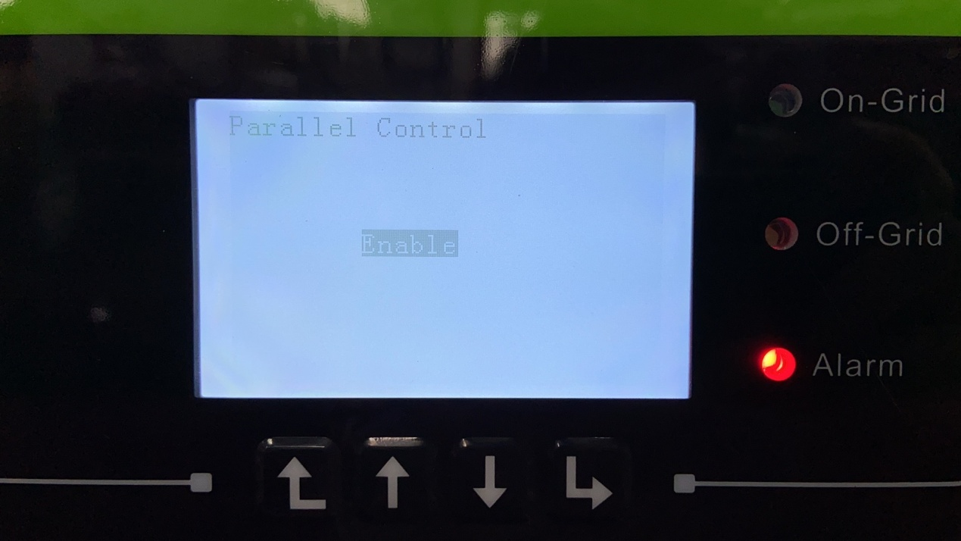
Set this inverter as master inverter
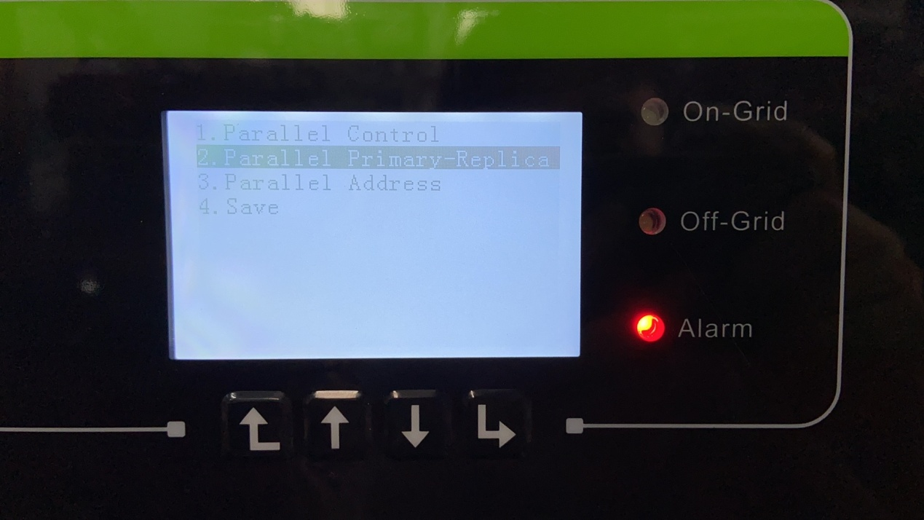
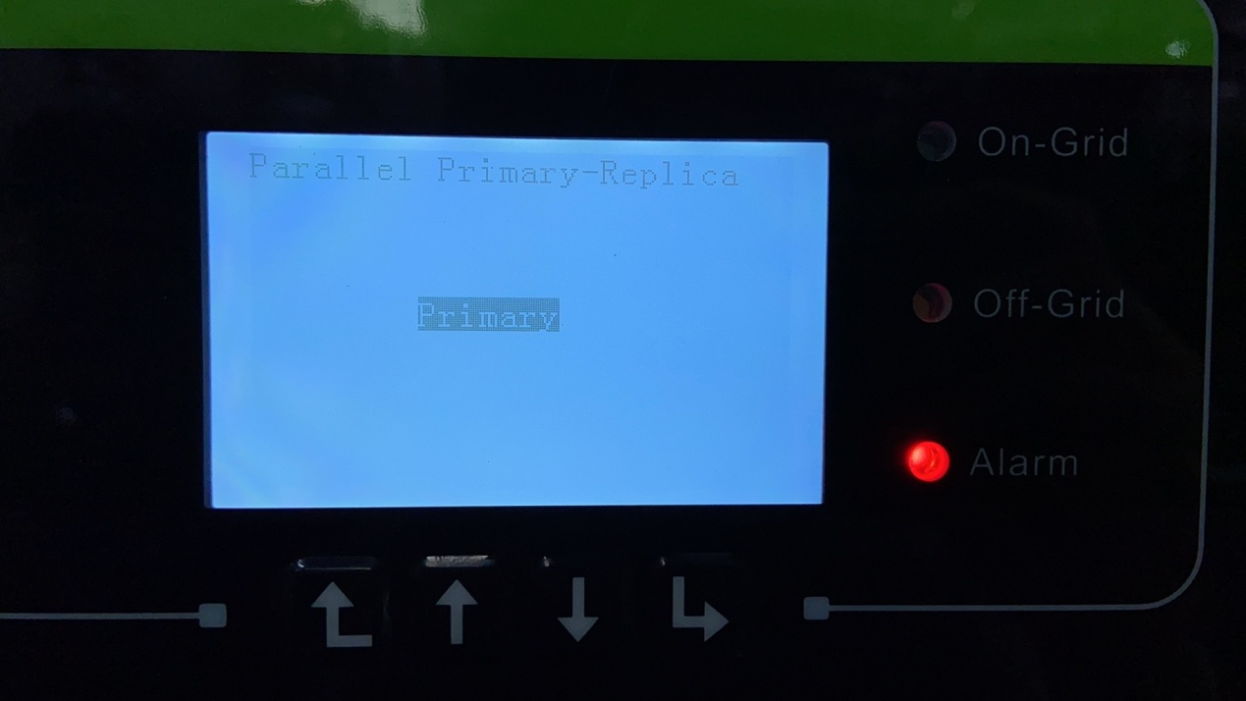
Set Parallel address: 00
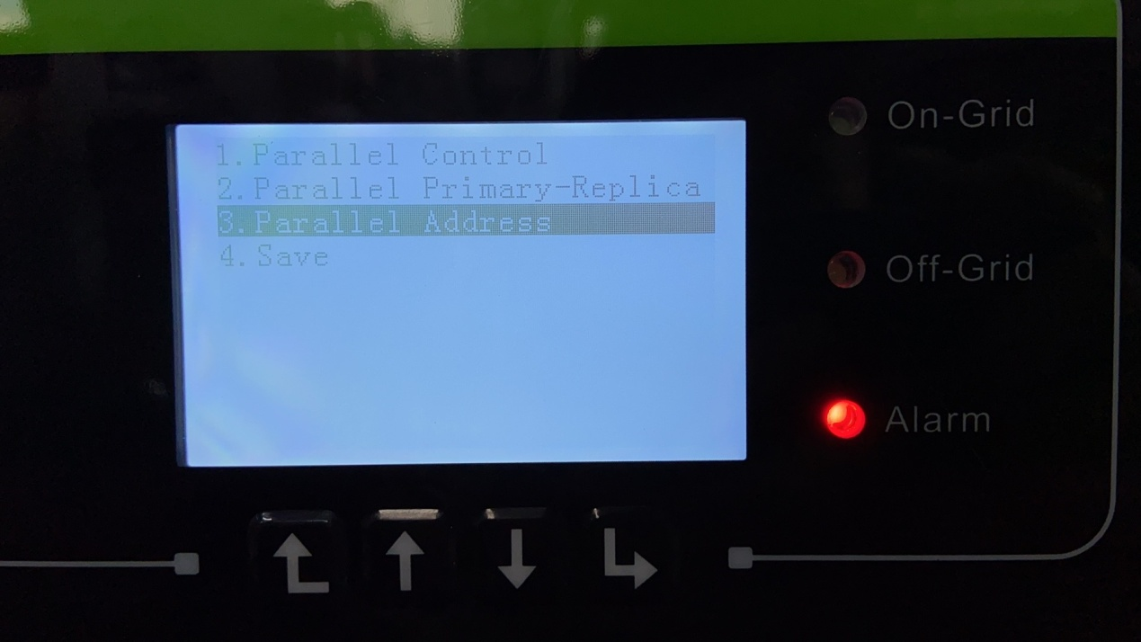
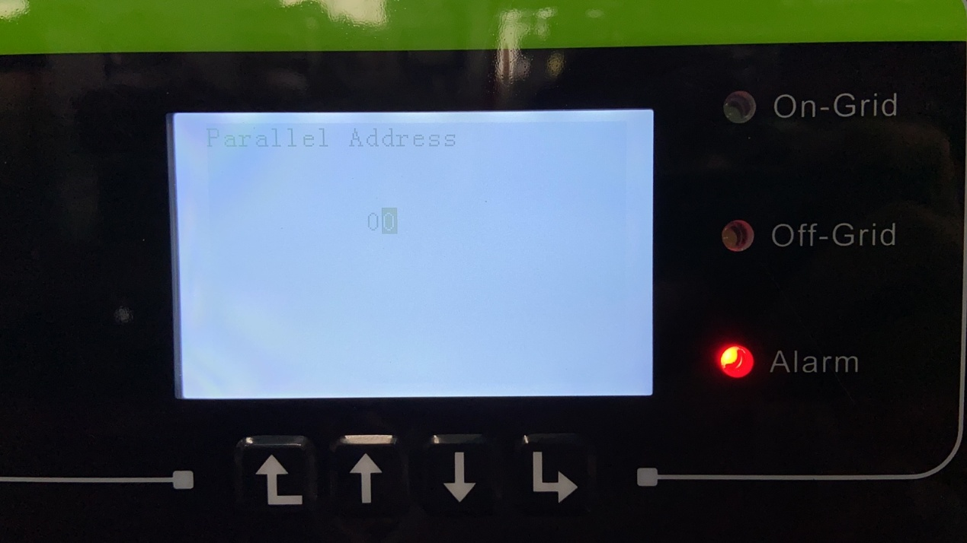
Save the setting
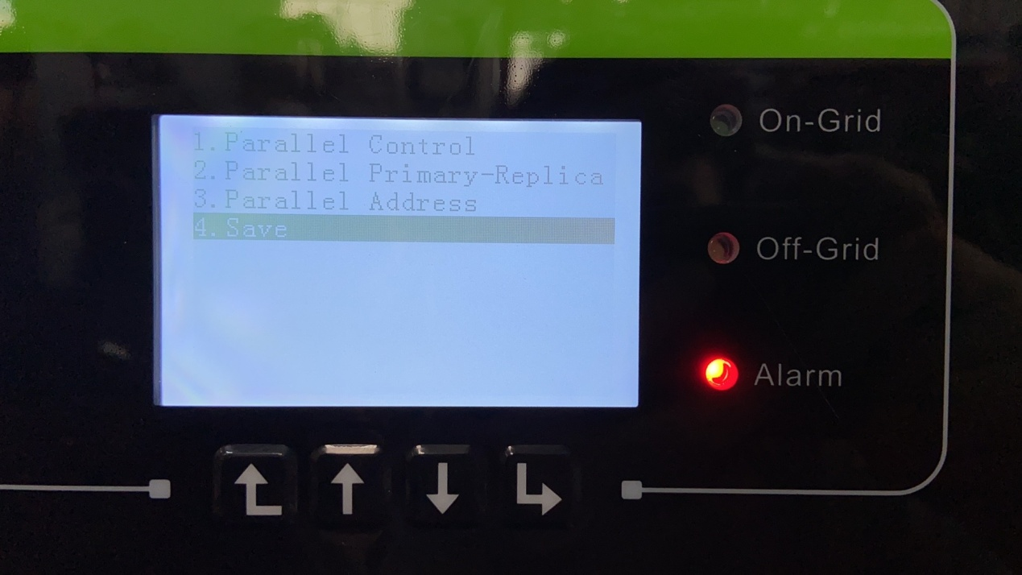

Use the same way to set slave inverters, the parallel address can’t be same, they need to be from 00-10.
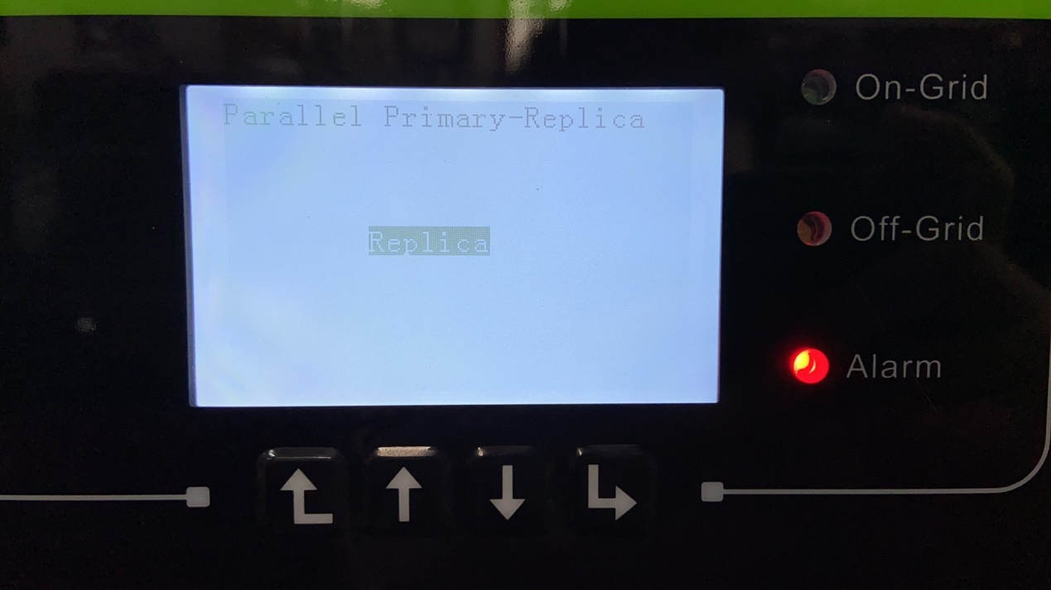
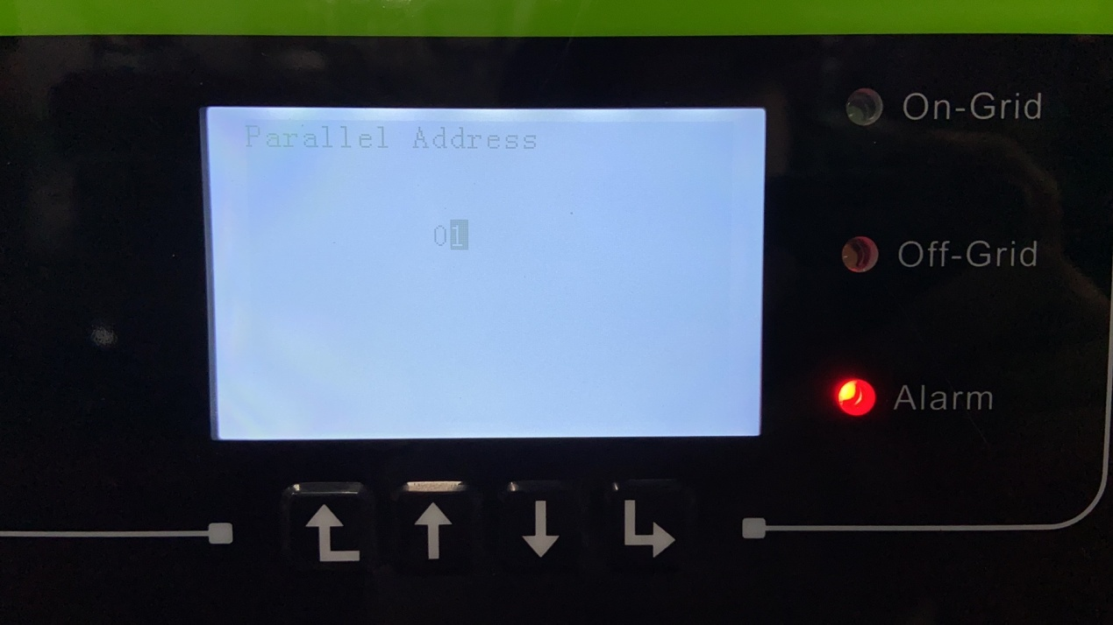
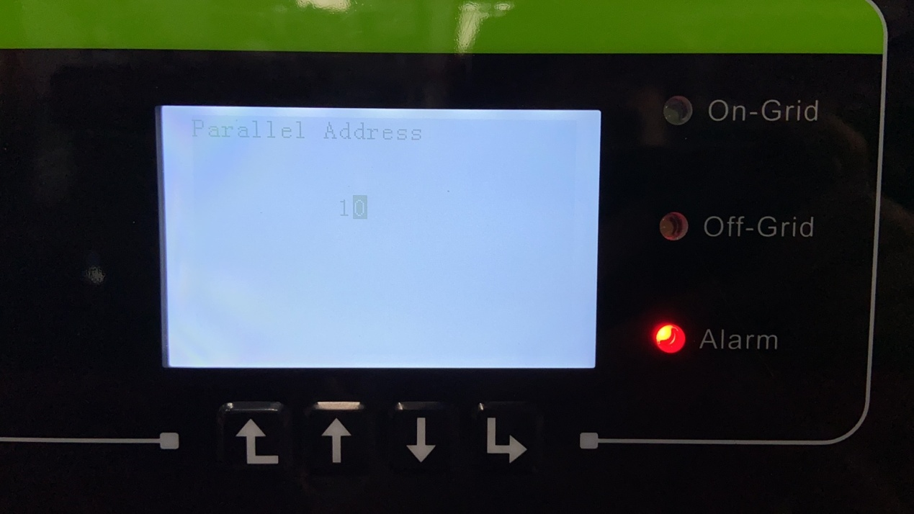

After setting according to the above steps, check whether the inverter reports other faults (except for grid under-voltage/ grid under-frequency),
If there are no other faults, you can turn on the AC switch to set the master work mode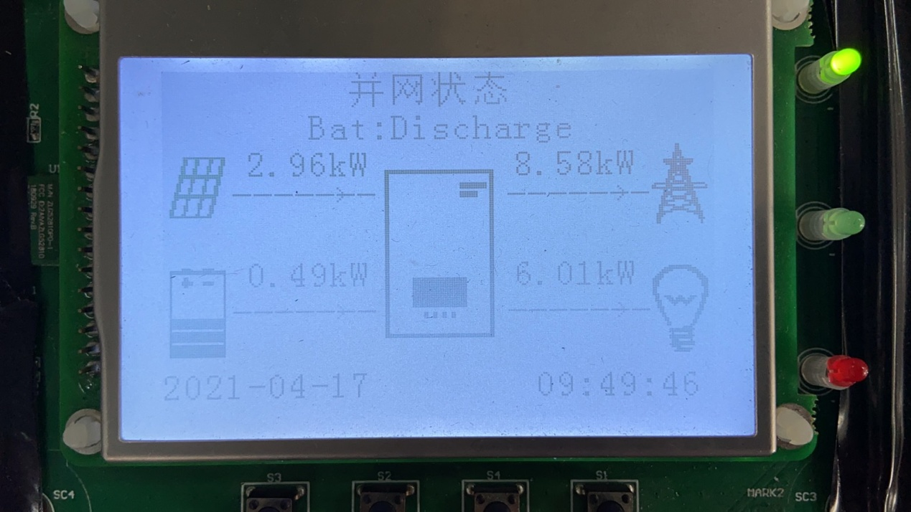
Note:
1. For parallel operation, ensure that the hardware version, software version, and safety country of each machine are consistent
2. If the master inverter is not connected to the battery, the inverter cannot work offgrid.

